

ELE494-08

Autonomous Robotic Systems

Project CTE Document 1

Yousif Khaireddin

63618

Dr. Shayok Mukhopadhyay

**Initial Goal Statement**

Throughout our project, we how to create a robot with accurate position estimation that will be able to survey an area and obtain the location of maximum light intensity.

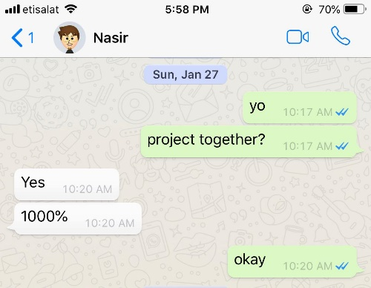**Team Formation**

Nasir and I have previously worked on many other projects together, so we already understood the way we both thought and assessed different scenarios. For this, as seen in the picture on the right, as soon as the project was announced in class, I messaged Nasir to ensure he would work with me.

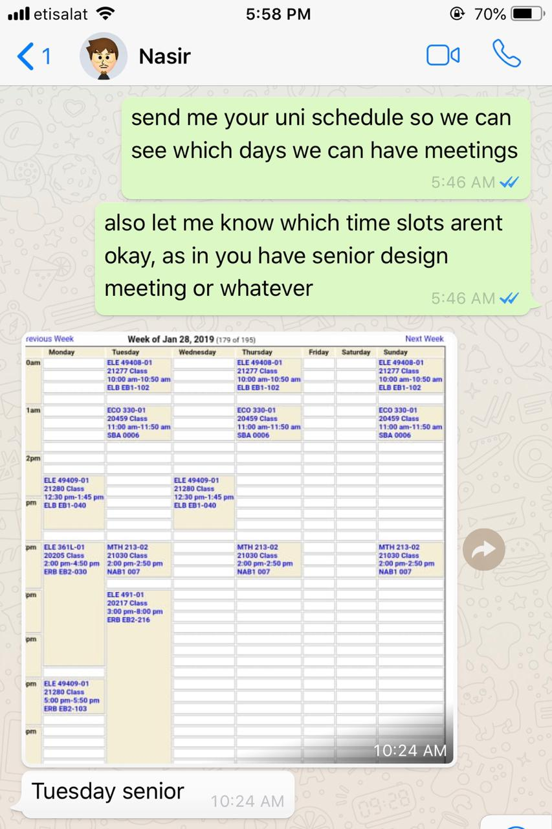

Once we established that we are working together, I set up our first meeting on where we did some initial research regarding different topics we could work on.

The outcomes of this meeting are listed below.

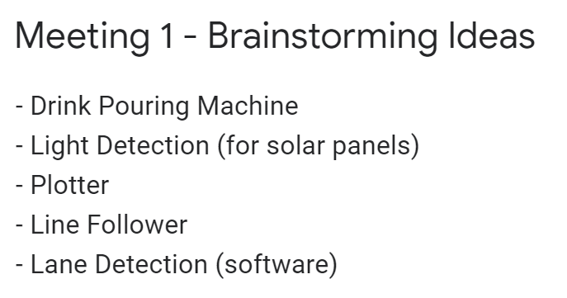

We then set up a meeting with Dr. Shayok to discuss all our ideas, help us develop the, and help us narrow down our options regarding what is and is not possible though the knowledge we will attain in this class. Eventually, we agreed on locating the area of maximum light intensity within a region.



**Team Member roles**

Since Nasir and I are really busy throughout the week, we usually have one meeting on Thursday which lasts around 3-6 hours between research, coding, building, and so on. For this, there hasn’t been a very clear division between the roles.

However, so far, Nasir has been the one responsible for developing the code to run the motors, I have worked on the code shown below which is required for utilizing the Ultrasonic sensor in distance measurement, and both of us have worked together on actually constructing the robot which is shown on the next page. When constructing the robot, I was the one responsible in deciding the location of the different components, and both of us worked together in wiring and soldering everything.

The following code was written to test the ultrasonic sensor

#include <hcsr04.h>

//pin definitions

#define TRIG_PIN 5

#define ECHO_PIN 4

HCSR04 hcsr04(TRIG_PIN, ECHO_PIN, 20, 4000);

**void** setup(){

Serial.begin(9600);

}

**void** loop() {

Serial.println(hcsr04.ToString());

delay(250);

}

Regarding hardware, after researching the workings of the different components, I sketched the following circuit diagram to give the both of us a better idea of how we could implement motor control and ultrasonic distance measurement. Once we had agreed on the connections, we worked together to actually build the robot (as seen on the next page) according to this.

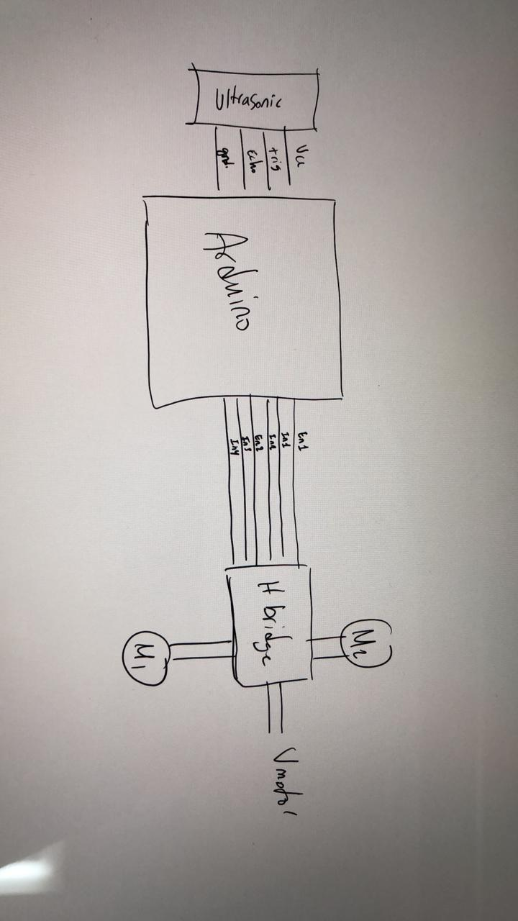

Regarding the rest of the project, we require incorporating two encoders and a gyroscope regarding hardware, and actually programming the robot to identify its position in terms of software. So, Nasir will be responsible for writing the programs for these components to communicate with the robot. I will be responsible for wiring and mounting these components onto to the robot, and we will both be responsible on developing the mathematics and the actual program regarding accurate position localization and estimation.

**Team Strengths and Weaknesses**

|  |  |  |
| --- | --- | --- |
|  | **Nasir** | **Yousif** |
| Strengths | Experienced w/ Arduino  More free time in schedule | Experienced w/ RaspberryPi  Better at developing circuitry  Handy work  Lives in dorms |
| Programming  Good team communication  Strong researching capabilities | |
|  |  | |
| Weaknesses | Procrastination | Time management  Doing multiple projects this semester |
| Limited knowledge of mechanical systems  Limited knowledge in accurate positioning | |

**Broad Objectives**

As agreed with Dr. Shayok throughout our meetings, we have decomposed our project into simpler and simpler sub projects. Depending on our ability to progress through our ideas and complete the tasks required, we will develop the project further. So, we will initially start with performing accurate position localization within a region. Once this is completed, we could develop the robot further to allow it to detect the light intensity of the area it is in. Should we complete this, we will then move on to detecting the area of maximum light intensity within an area and optimizing the rate at which the robot can reach there. Next, we could work on obstacle avoidance or path planning while performing this task.

To get us started, we purchased a Arduino car kit as can be seen below.

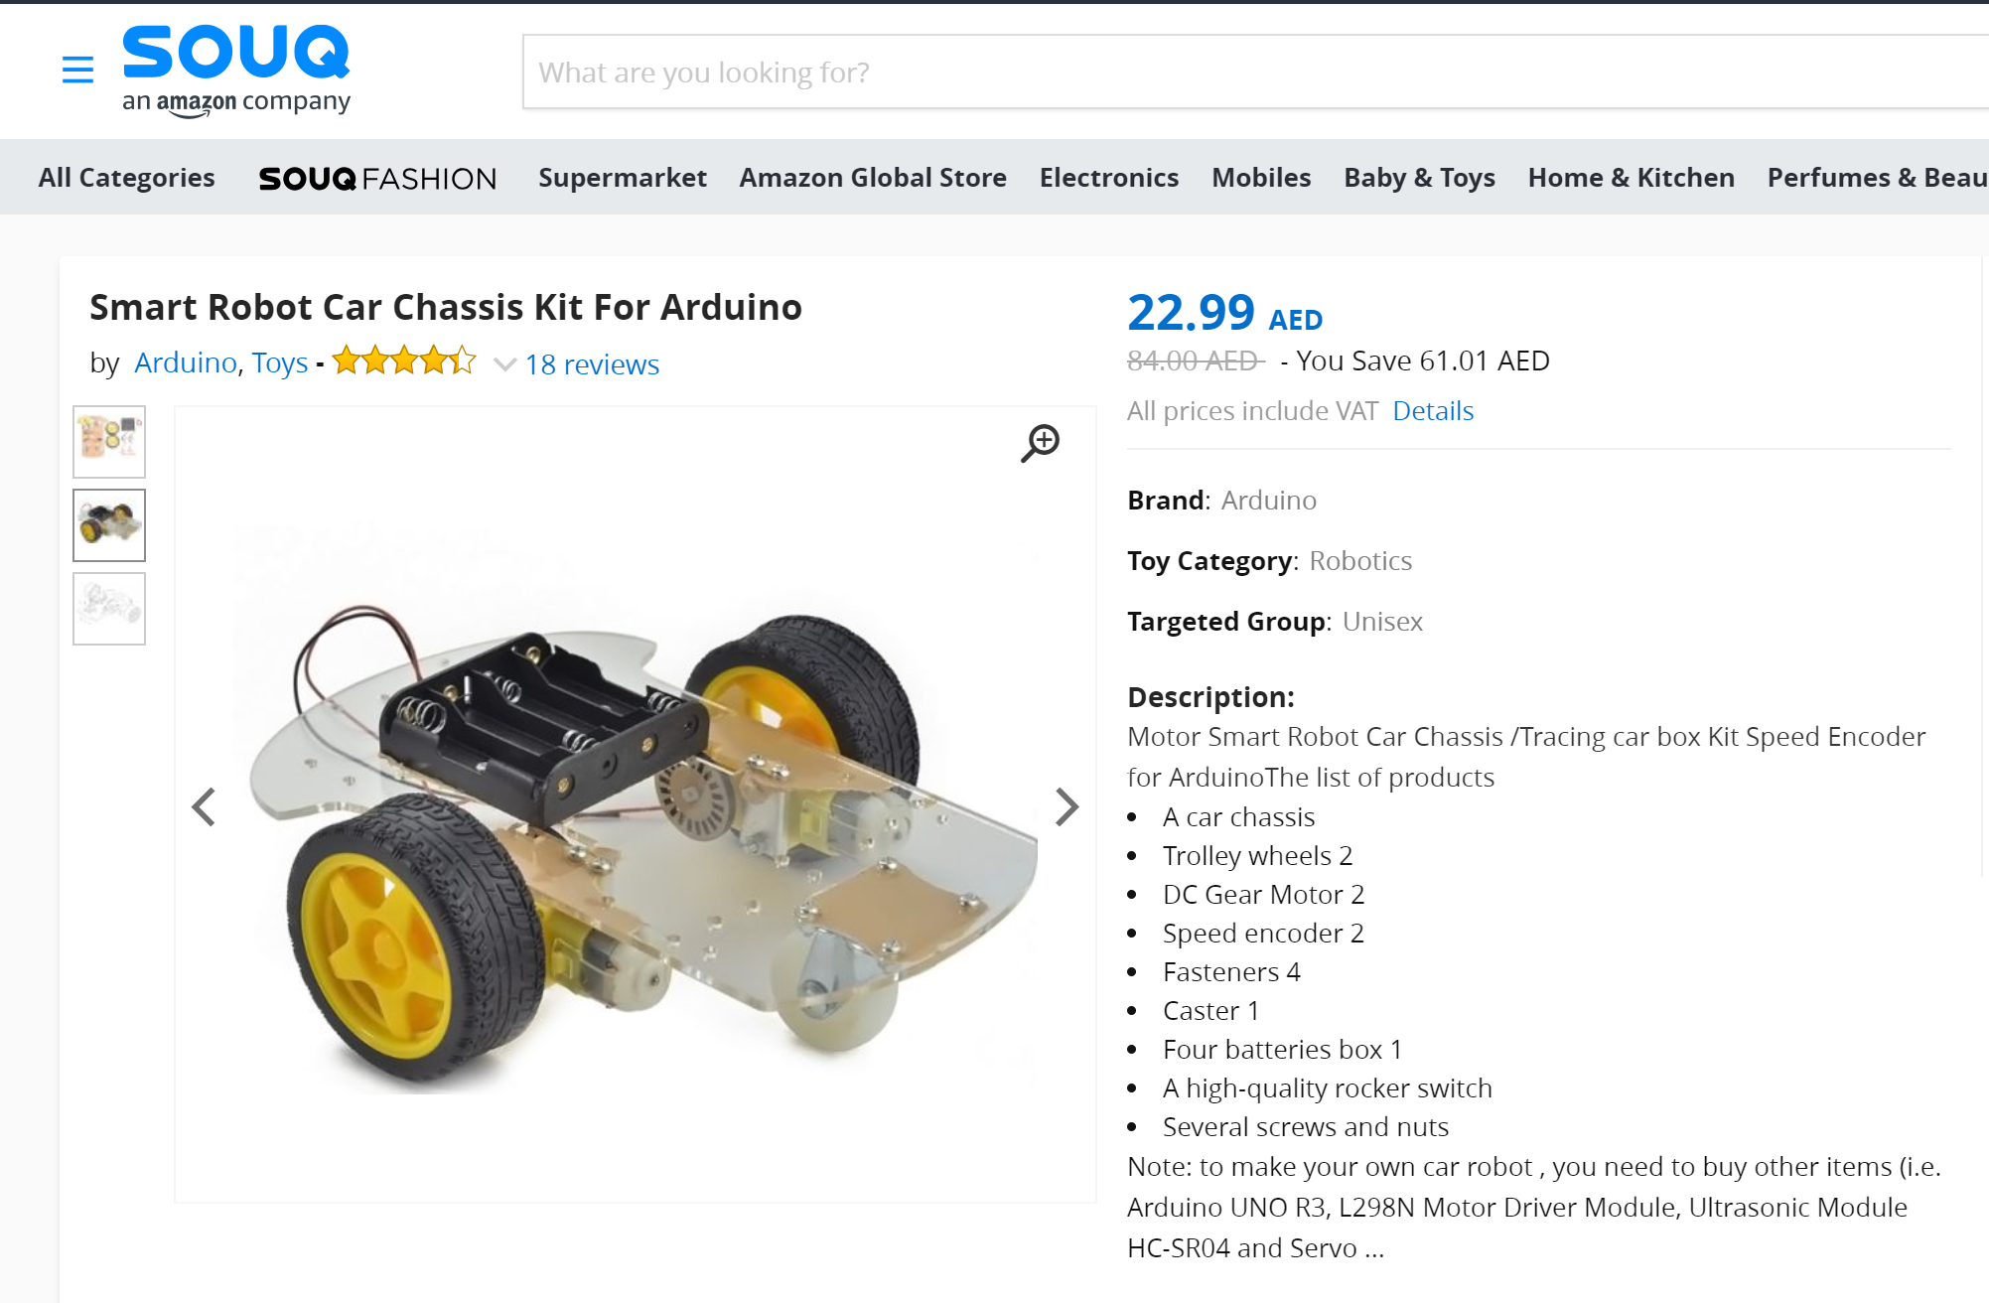

Over the past two weeks, we built and modified this kit, yielding the following.

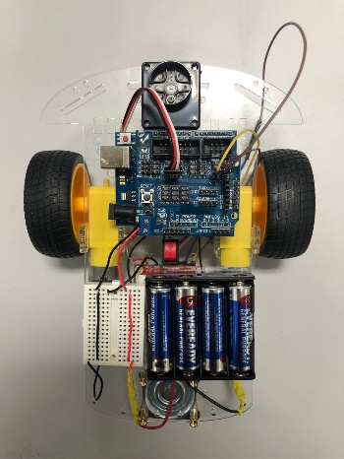 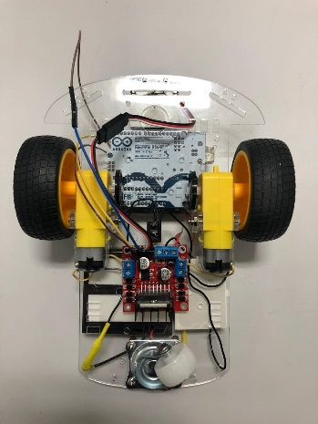

Moving on from here, as mentioned earlier, we hope to incorporate two encoders and a gyroscope to aid us in positioning. We have already purchased these parts and are waiting on their arrival.

Next, we hope to develop a the Kalman filter required to help us transform these velocity and acceleration readings into usable data for distance measurement.

After developing this program, we can move onto adding the light sensors (LDRs) and interfacing them with the robot to help us detect the light intensity as we travel and use this information to detect the area of maximum light.